Project Proposal
EECS 581 Fall 2017

Team Name: Team 6

Team Members and email addresses:
Ashley Hutton (ashley.hutton@ku.edu)
Hannah Johnson (h724j464@ku.edu)
Rabel Marte (rabelmarte@ku.edu)
Joshua Wu (joshuawu@ku.edu)

Contact: Hannah Johnson

Team Meeting time:
With Dr. Johnson: 4:30-4:45pm
Without Dr. Johnson: Wednesdays 4-6pm

Lab Meeting time:
Monday 11am

Project Description (150-250 words)
- We believe that everyone should have access to an intelligent financial advisor tailored to their specific needs. More than a majority of millennials do not seek financial advice from professionals. Due to the lack of guidance, millennials will learn the consequences of their financial actions such as undertaking large amounts of loans, not investing for their retirement, and much more the hard way. Even if millennials were to seek online resources, the information would be scattered and not tailored to their specific situation. Project-581 seeks to solve this lack of guidance by streamlining the advising process, connecting all of the user’s financial data, and analyzing different options to best complete the user’s financial goals.
- The end result of this project will be a web application where users can provide their financial data, describe their financial goals, and receive recommendations on how to best achieve such goals. Project-581 will serve as the central source for the user’s finances and users will be able to see the trajectory of where they are financially heading. One of the emphasis of Project-581 that sets it apart from other financial applications is the focus on how users can achieve their financial goals given their current situation. Project-581 will be an application that users can use throughout their lifetime to receive guidance on the many financial situations that they will face.

Project Milestones

First semester:
- Acquire and research required resources and APIs. Completion date: 10/6/17.
- First prototype/wireframe mock-up. Completion date: 10/20/17.
- Complete requirements document of all possible user interactions with app. Completion date: 10/20/17
- Ethnographic user research in the form of user interviews. Completion date: 11/17/17
- Set up/configure cloud platform (Heroku) and establish connections to our application. Completion date: 11/17

Second semester:
- Implementation of front-end MVP: 2/3/17
- Implementation of back-end MVP: 2/3/17
- Second phase of user research to identify what we could improve in user flow. Completion date: 2/20/17
- Generate requirements from feedback (as well as documentation) and implement improvements. Completion date: 3/2/18
- Second round of QA, code refactoring. Completion date: 3/23/18
- Second round of project feedback and implement improvements. Completion date: 4/13/18
- Last round of QA. Completion date: 4/27/18

Gantt Chart can be accessed here: https://drive.google.com/file/d/0BxCBRdusrEUZS0RkTk43M0lGb3c/view?usp=sharing

Project Budget
Estimated cost: $0

Project-581 will be minimal in cost. We are developing a web application with no hardware needs. Our project will be hosted on Heroku using their Free plan. If we discover we need to upgrade to the next tier (“Hobby”), our costs will be $7/month to host our project. Also, we will rely on the free (testing) tier of API’s for the MVP of our project. We do not foresee any special training to implement our app.

Work Plan
- Ashley:
  - Backend development
  - Database management
- Rabel:
  - Backend development
  - Database management
  - Retrieval of data from API’s
  - MVP validation by interviewing possible users
- Hannah:
  - Initial wireframing (pencil and paper, Sketch app)
  - Interactive prototype of higher fidelity front-end mock-ups (Marvel app)
  - Development of front-end views (HTML, CSS, Bootstrap framework)
  - User Research
- Josh:
  - Backend development
  - QA/code refactoring

Github link: https://github.com/rabelmarte/project-581

Preliminary Project Design

At a high level, our web application is aiming to work for our users as a financial advisor may work for them in real life. Users grant us access to their banking information and share their goals with us, and in return we will recommend them ways to efficiently reach those goals as well as track their progress along the way.

To implement our web application we are using the framework Ruby on Rails which uses the model-view-controller principle to divide the application’s implementation into three interacting sub-systems.

Our application will be focused around six models: Goals, Accounts, Transactions, Users, Recommendations, and Portfolios. We organized our models in this way to ensure that the user is the center focus of the application. As you can see from the ER diagram below, everything flows from the User model. In our application, users will have accounts that keep track of transactions, a portfolio to summarize their finances, and goals that motivate recommendations.

Ease of use is one of the most important parts of our application. We don’t want the users to focus on the numbers. As a financial advisor, Myne will interact with users in a way that makes it simple to recognize steps that need to be taken to achieve their goals. For example, if a user wants to pay off their student loans, we would first take a look at their transaction history. If that user has unusually high spending in any category (ex. fast food), our recommendation would be to lower spending in that category and pay that money towards their student loan debt.

We will have algorithms based on the type of goal the user is trying to achieve. For the MVP, we are addressing three goals: debt, retirement, and general savings. Below we will go into detail about each of the goals and the algorithm that will be used to determine the recommendation for the user.

Debt goal:

Given the transaction history for a user, and the average spending of an American in that category, we will define the surplus as the amount a user spends over the average. For example, if the national average spending amount of fast food is $100/month and our user spends $150/month, the surplus would be $50.

We will have information about the debt the user is trying to pay off. This information will include: amount owed, interest rate, length of loan, and minimum payments. The goal defined by the user will be to pay off the goal at a certain point in time (ex. in the next 5 years).

Our algorithm will first look at the transactional surplus from a user and decide if that surplus amount, plus what the user is currently paying towards their debt, is sufficient to pay of the goal in the goal time frame. If it is, we will recommend that they reduce the surplus amount from their spending in that category and instead pay it towards their loan. If it is not, our algorithm will explore other options.

When exploring other options, we will first look at their interest rate to see if there is a service that will allow them to refinance their student loan with a lower interest rate. The second route we will take is to see if the user can reduce spending in a category to an amount lower than the national average. We do not want to force the user to make sacrifices, which is why we are offering this as a final option. If none of these routes seem feasible or desirable, our algorithm will tell the user that the goal is not realistic and would suggest a new goal.

Our other two goals, savings and retirement, will have algorithms that follow a similar methodology. Our overall goal is to give the user options to achieve their goals while also being realistic and acting as a human financial advisor. If a user’s goal is too lofty, we will tell them. On the other hand, our algorithms will make recommendations that will not force the user to make unrealistic financial decisions.

At its core, our algorithm will have inputs such as the financial situation and goal of the user and generate an output, in the form of a recommendation. A specific example on how this algorithm is used would be in assisting users with paying off their loans. When a user inputs that they have $30,000 in loans as part of their financial situation, their transaction history would then be pulled and it would be seen that they spent $300 in fast food. The output would then be generated in the form of recommending the user to spend $100 less on fast food and use the savings to pay towards paying their loans.

The front-end of our application will be designed using HTML, CSS, and the popular CSS framework called Bootstrap. Ruby code embedded into our HTML views will populate the otherwise static pages will relevant data for our users. Our views will be designed to reflect the wireframes we created this semester using the Sketch app. We want to craft a highly personal experience for our users that mimics the style of real-life interactions with a financial advisor. Words that we want to come into our users minds when using Myne are concise, friendly, connected, consistent, and invested. To reach this goal, we will put an emphasis of effective UX Writing methodologies throughout our design.

The user flow is briefly described as follows: upon registration, users are directed to the beginning of a survey in which we collect more information from them such as their name, location, birth date, marital and employment statuses, education level, and living situation. They are allowed to exit this survey and return to it later at any time. After we collect this information we allow users to connect their banking information through an API we’ve chosen to use called Plaid. They are also allowed to do this at a later time if desired. At this point, users can start creating their financial goals. They can select which type of goal they are interested in creating, name the goal, and then enter in additional financial information pertaining to their chosen goal type. Then, our algorithm will create recommended plans of action for the user that they can choose from. After they choose a recommended plan, their goal will appear on their homepage where the user can track its progress. For more specific details of every user action refer to our Requirements Document.

Wireframes for our application can be found here: https://drive.google.com/drive/folders/0B93AfWM2ubDEQkwtM211NlNlekE?usp=sharing

Figure 1: Entity Relationship Diagram
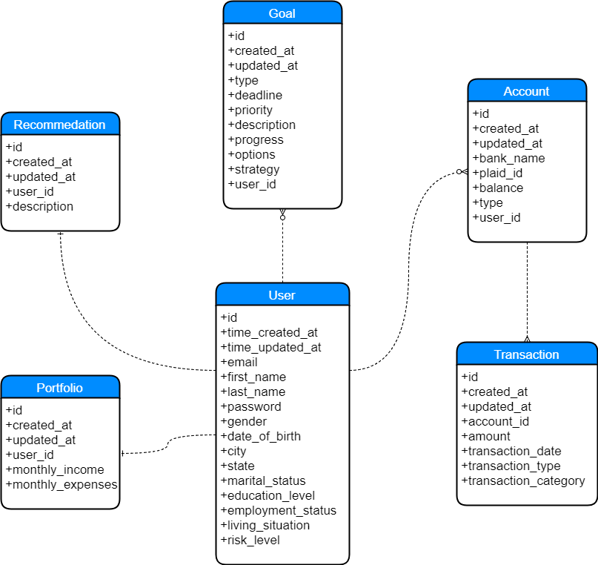

Ethical and Intellectual Property Issues

Ethical Issues

The first ethical issue that presents itself involves a potential business model for Myne. As a personalized financial advisor, Myne could generate revenue by recommending specific financial products that would help in achieving our users’ goals. Depending on Myne’s priorities, we would need to make sure that we place the interest of the users over ours. In other words, as an application that provides personalized recommendations, we would need to recommend financial products that are in the best interest of the users but not necessarily the products that would lead to the most revenue. This is similar to an ethical dilemma that traditional financial advisors face where they must choose between selling a product that increases their bottom line or recommending a product that is best for the advisee. We do not have to sacrifice the interest of our users to make money. Instead, by acting in the best interest of our users, they will keep coming back for more advice and will consequently lead to more revenue.

Another ethical issue that Myne will encounter involves the financial data that we will be collecting. For example, we will be collecting very personal data such as how much individuals make and their financial goals. Because of this, Myne will be the central source of all the financial data of an individual. Myne is then able to analyze all of that data and make recommendations that other financial institutions could not make. This conglomerate of data will be very valuable to financial institutions because they cannot individually produce it. At the end of the day, our goal is not to sell data for advertising purposes, but our goal is to use this data to make better financial recommendations.

Finally, another ethical issue that Myne will face is dealing with how little fintech startups are currently regulated compared to traditional financial institutions. Fintech startups do not operate like a bank or an insurer, so they are not subject to the same regulations that would govern more traditional institutions in the financial system. For example, given a specific financial institution, it is very clear which agency regulates it such as the Consumer Financial Protection Bureau, the Financial Industry Regulatory Authority, and etc; it is not so clear for fintech startups. However, just because fintech startups are currently not regulated as much, it does not mean that such regulations that apply to other financial institutions should not apply to fintech startups. Therefore, if Myne seeks to be a leader in giving personalized financial advice, we must closely observe the regulations that apply to other financial institutions and follow their intent even if it complicates our process.

Intellectual Property Issues

At its core, the most important part of Myne will be the algorithm that takes financial data and goals as an input and outputs recommendations on how to achieve such goals. Therefore, we would want to establish this algorithm as a trade secret and take the necessary actions to control disclosure of such algorithm. We choose to not patent our algorithm because then we would be exposing to other financial institutions how we provide our recommendations. By keeping the algorithms as a trade secret, we are able to control the source code indefinitely and our competitors will not be able to replicate our results. However, what this means is that we will need to require confidential agreements, limit access to source code, and other measures to reduce the chance of our trade secrets being leaked.

Using algorithms to provide financial advice and recommendations for various financial situations is something that no major financial institution is tackling. To take advantage of this, we would want to be very strategic with our trademarks so that we are easily recognized as the leading intelligent financial advisor that provides personalized advice. When people see our trademarks, we want them to think that the power of big data and technology is being used to find the best way to achieve and tackle their financial goals.

Change Log
- Changed the dates on our milestones for both semesters

